Wiscasset Community Center’s

February Vacation Camp

February 18th – 21st 7:30am – 5:30pm

**We will have 4 days of Exciting activities planned with Spirit Days and lots of other Fun Activities! A schedule is available on the back page to choose 1 day or come to them all!**

Some of the activities will include Swimming in the WCC Pool, Dance parties, a field trip Bowling/Arcade at Sammi’s Entertainment in Waldoboro on Thursday, Outside fun including Sledding with hot cocoa to warm up with after and even a Movie in the Gym on the big screen!

**Daily or weekly sign up available**

**Weekly Price:**$145.00 Member / $155.00 Community Partner / $165.00 Standard  
**Daily Price:** $40.00 Member/ $45.00 Community Partner / $50.00 Standard

*(Must have minimum of 20 kids to go Bowling)*

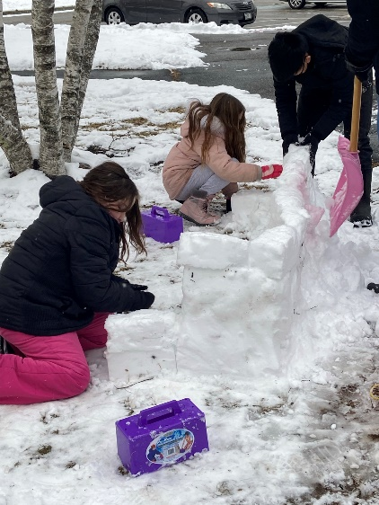 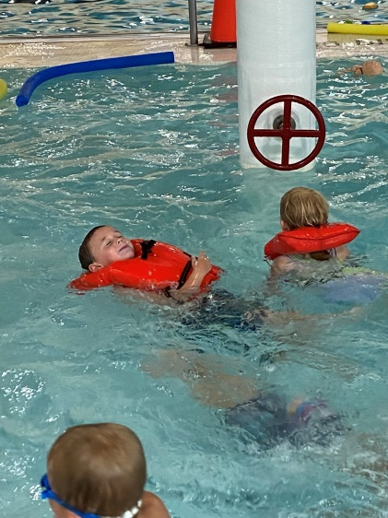 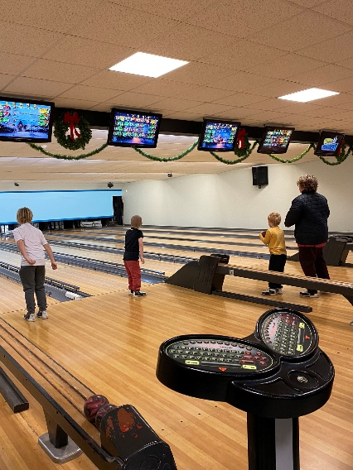

Sign up today online at [www.wiscassetrec.com](http://www.wiscassetrec.com) or call the WCC front desk for assistance 882-8230

Questions? Email Kristy Lincoln at [klincoln@wiscassetrec.com](mailto:klincoln@wiscassetrec.com)